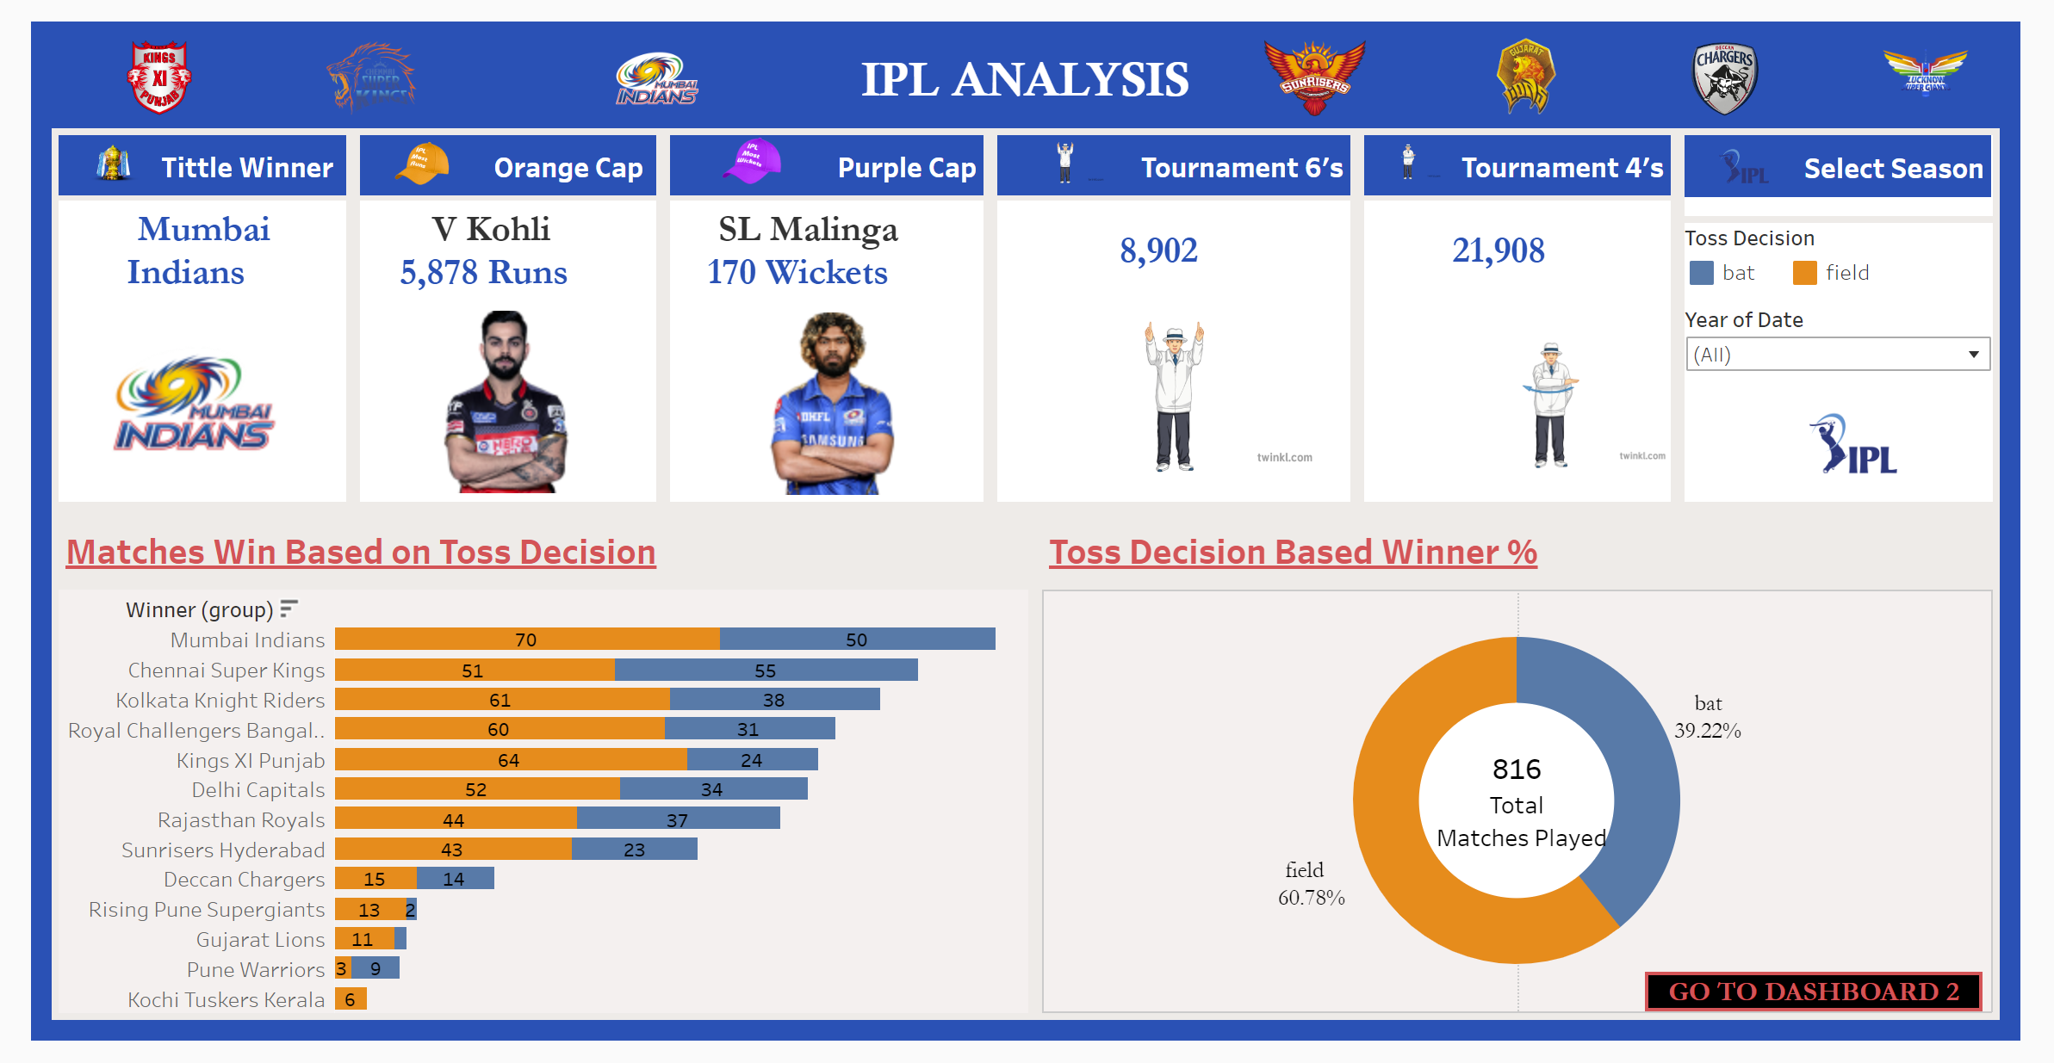 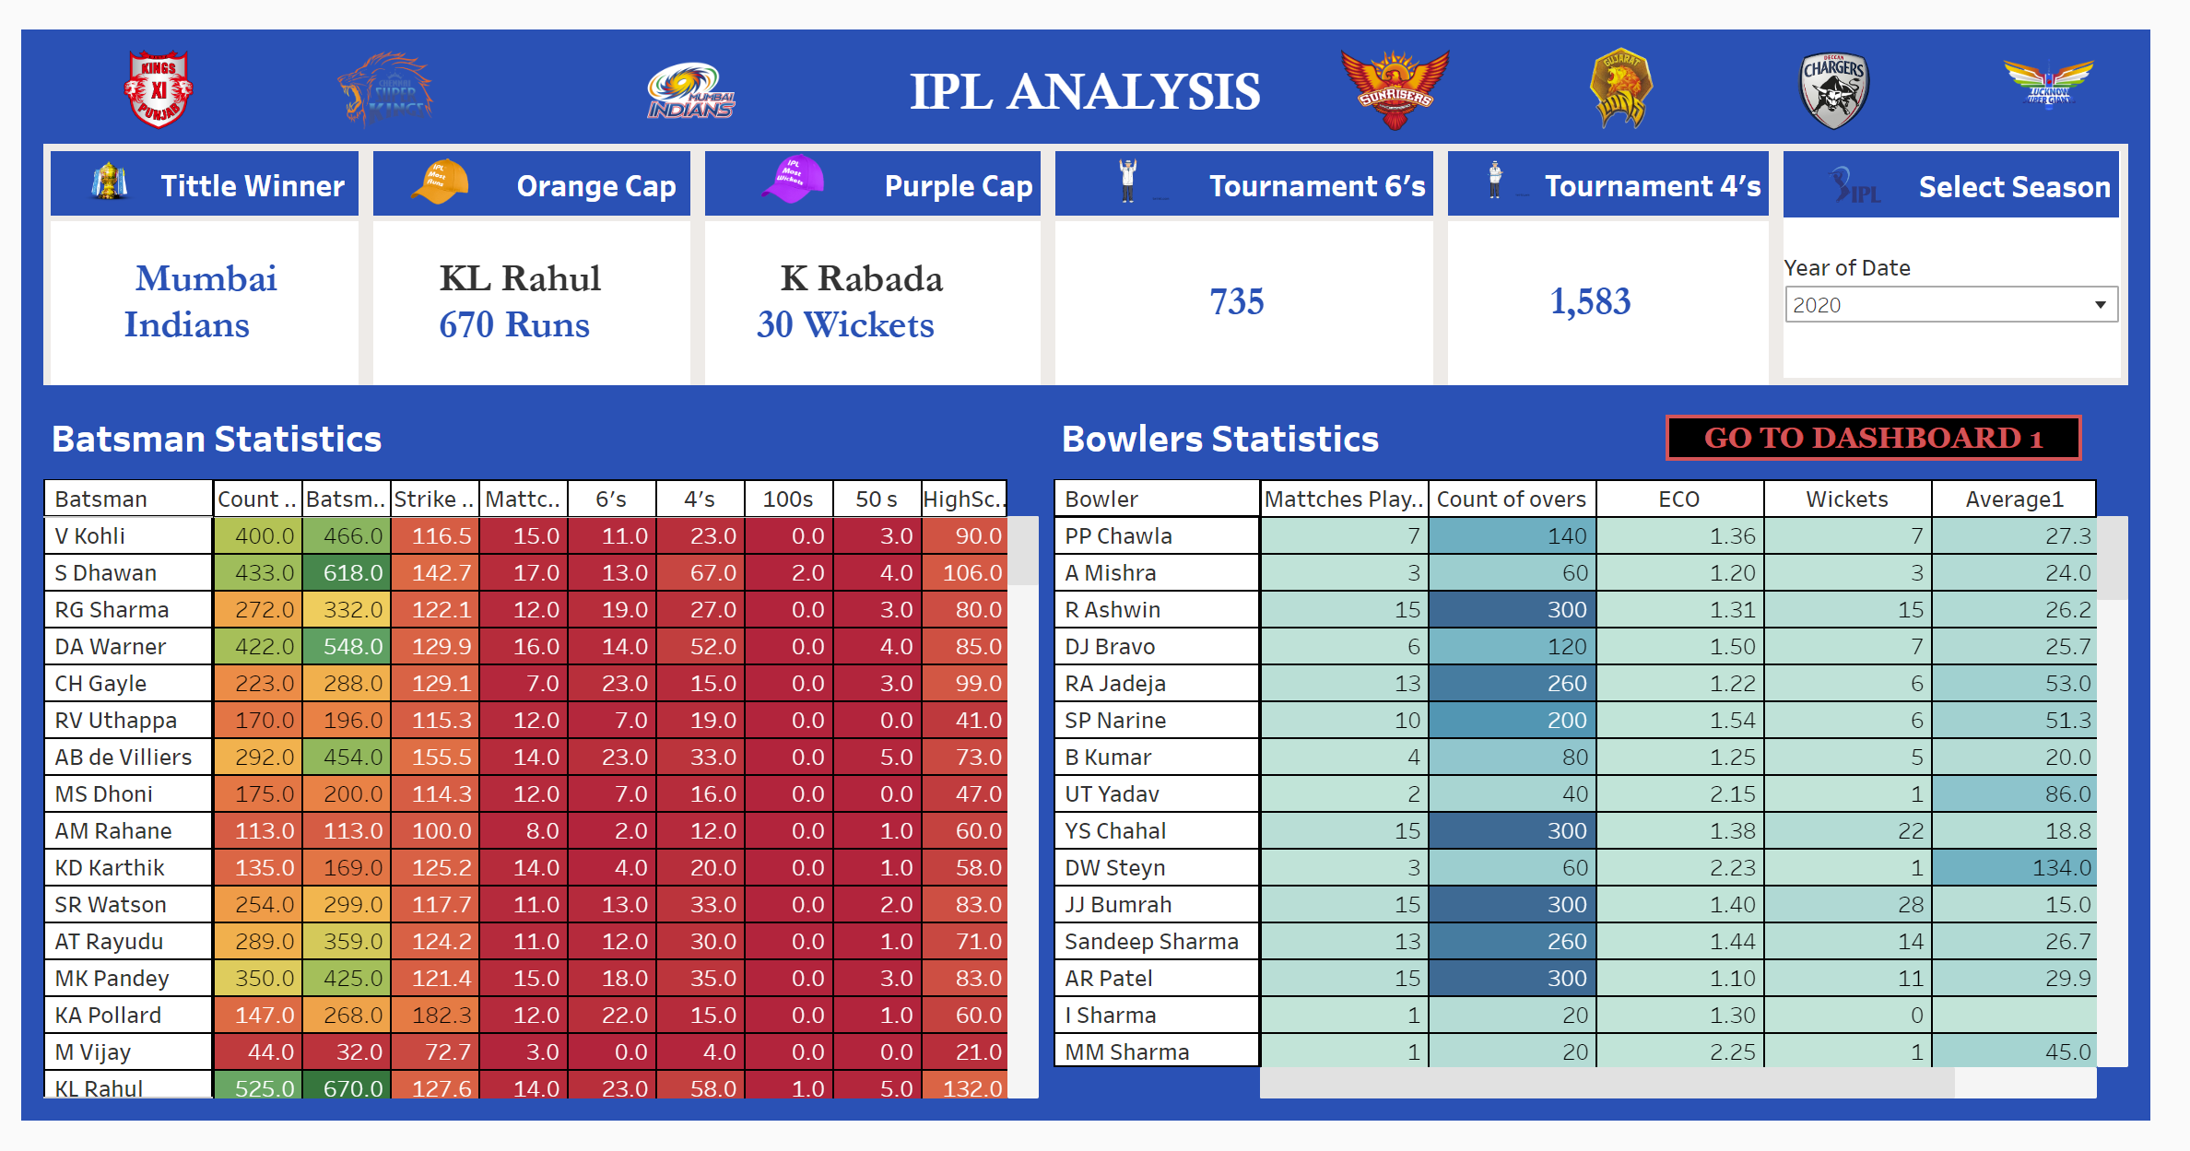

TABLEAU PUBLIC LINK: <https://public.tableau.com/views/IPLAnalysis_17091159326840/Dashboard1?:language=en-US&publish=yes&:sid=&:display_count=n&:origin=viz_share_link>